**REGULAR EXPRESSION REPORT**

Regular expressions is a powerful language for matching patterns of partial words, whole words, or even multiple words. While simple regular expressions are straightforward to use, you can create complex expressions that are powerful but may be difficult to predict and debug and may be difficult for other people in your organization to understand.

In this project, after explaining the subject of regular expression, the examples were shown by giving different patterns as input. I showed the appropriate word in red color. The user selects one of the sample patterns and tries to understand the subject by giving various inputs.

Where to Use?

Many programming languages, operating system commands, database queries and search applications uses Regular Expression. We are going to use it on HTML inputs for specifical input type like Social ID, phone number, email, credit card number and validation date etc.

How to Use?

Regex is abbreviation of the Regular Expression. Regular Expression is an expression that can be use in many programming languages and finds sections that match certain rules in numericand string content.

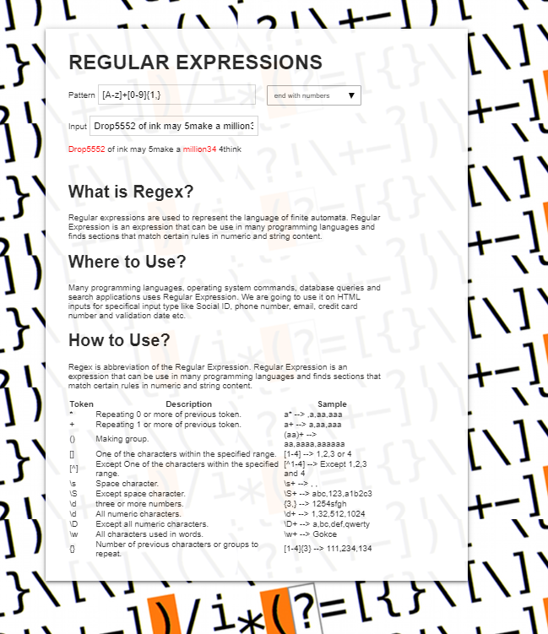

**GÖKÇE DAŞTAN--1521221053**